Case History: Inversion Modelling of Gold-Vein Mineralization using Matrix™ VLF-EM
Background
The Lingman Lake gold property consists of four free hold patented claims and 762 single cell staked claims. Total land package amounts to 15,372.3 hectares. 275.5 hectares of the property total include 14 mineral rights patents.
The property hosts an historic estimate of 234,684 oz of gold* (1,063,904 tonnes grading 6.86 g/t with 2.73 gpt cut-off) and includes what has historically been referred to as the Lingman Lake Gold Mine, an underground substructure consisting of a 126.5-meter shaft, and 3-levels at 46-meters, 84-meters and 122-meters depths.
Putting Matrix VLF into Action
In 2018, Terraquest Ltd. was contracted to perform a Matrix™ VLF survey over the property by Signature Resources. (https://docs.wixstatic.com/ugd/63a91d_529fe5654c7b43a3b7b2f0b9c1df58cb.pdf) describes their findings from the survey which introduced a new element into VLF-EM processing, namely Inversions, which provide cost-effective near surface mapping for gold targets.
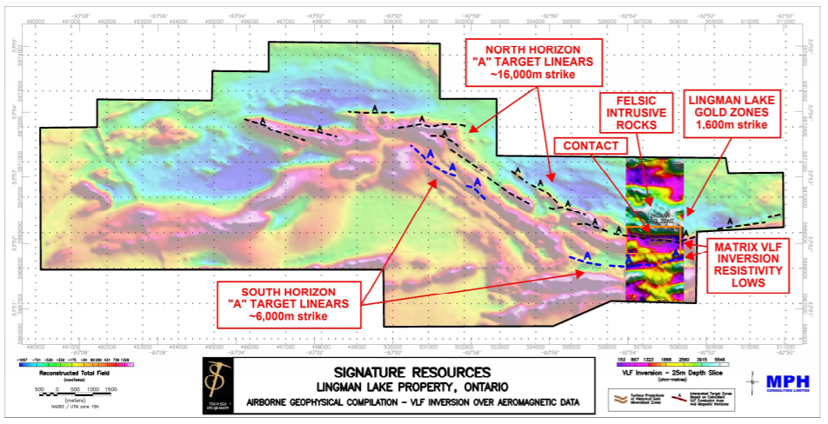
Figure 1: Integrated map with Matrix™ VLF-EM and reconstructed Total Field Magnetic Data.
Results are indicated below.
The results showed:
- enhanced resolution of the controlling contact between felsic intrusives and mafic metavolcanics.
- a distinctive, broad resistivity low that correlates with a known mineralized, gold vein system and alteration (Lingman Gold Deposit) and numerous other occurrences along a 22 kilometre strike, even where thin surficial conductivity is present as shown by the total field VLF data.
- that the depth slices are unimpaired at depth by known surficial conductivity, as shown in the 40 metre resistivity depth slice presented in the press release.
Applying a New Interpretation Approach to Greenstone Exploration
Inversion is a method that develops a model of the data from a priori acquired geophysical data. It is typically applied to magnetic and other forms of data, in this case, VLF-EM. With this data, the objectives were to:
- Characterize rock types by their inherent resistivity
- Enhance the resolution of contacts between lithologies
- Augment the conductor axis provided by the total field amplitude
- Identify resistivity lows commonly associated with contact zones, alteration, and mineralized structures
- Surface mapping can be continued downwards by progressive depth slices
- Map the surficial conductivities separately from the deeper bedrock responses.
In this case, a detailed inversion was performed on the data, which to our knowledge, is the first time airborne VLF-EM data from a typical greenstone terrane in North America have been inverted. The interpretation successfully enabled refinement of high priority targets and definition of key geological features.
In summary, resistivity products -- derived from the inversion of airborne Matrix™ VLF-EM data from a typical greenstone belt with thin overburden -- provide an inexpensive technique to identify and map near surface bedrock lithologies; structure; alteration; and mineralization in gold exploration.
For More Information
Terraquest would be pleased to discuss Matrix™ VLF surveys and interpretation approaches with you, including inversions of existing or planned data. For more information, click here <LINK to EASY-QUOTE form>.

